**ME 111 Engineering Drawing**

**Lab 9 Intersection of solids Wednesday Batch**

1. A cylinder 50mm dia. and 70mm axis is completely penetrated by another of 40 mm dia. and 70 mm axis horizontally Both axes intersect & bisect each other. Draw projections showing curves of intersections.

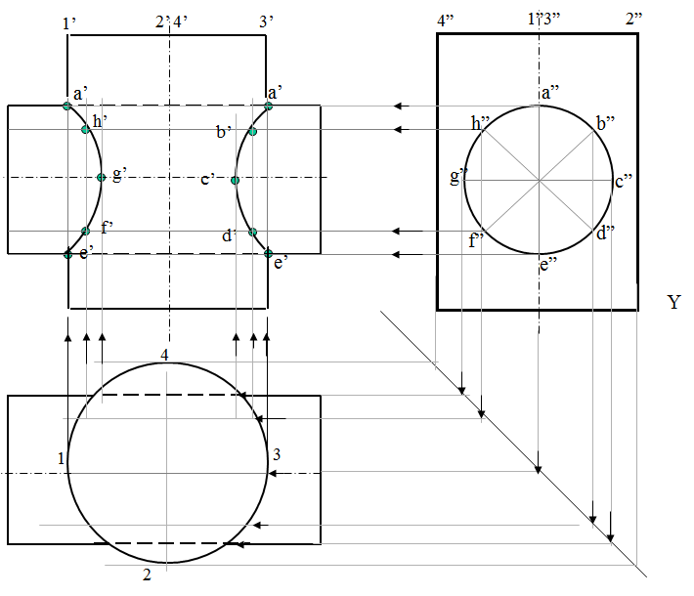

1. A cylinder 50mm dia. and 70mm axis is completely penetrated by a triangular prism of 45 mm sides and 70 mm axis, horizontally. One flat face of prism is parallel to Vp and Contains axis of cylinder. Draw projections showing curves of intersections.

